16.28: a) The fundamental frequency is proportional to the square root of the ratio 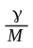
(see Eq. (16.10)), so

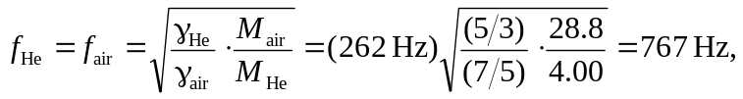

b) No; for a fixed wavelength , the frequency is proportional to the speed of sound in the gas.

